STUDENT Joseph Roper

Salford City College | Future skills

BTEC National 90 Credit Diploma in Creative Media Production

Unit 66: 3D Modelling

Contents

What is 3D Modelling? 3

Studio Workflow 3

Idea & Concept 3

Research & Planning 3

Modelling 3

UV Mapping/Texturing 3

Rigging 3

Animation 3

Animation in 3D Modelling 4

Path-Based 4

Inverse Kinematics 4

Forward Kinematics 5

Particle Systems 5

Applications of 3D 5

Models 5

Product Design 6

Animations 6

TV & Film 7

Web 7

Games 8

Virtual Reality (VR) 8

Education 9

Architecture 9

Displaying 3D 9

Application Programming Interface (Direct 3D & OPENGL) 9

Graphics Pipeline 10

Rendering Techniques (Radiosity, Ray Tracing) 10

Culling Methods 10

Lighting 11

Textures 11

Shadowing 12

Vertex/Pixel Shaders 12

Geometric Theory 13

Vertices 13

Lines/ Curves 13

Edge 13

Polygons 13

Faces 14

Meshes 14

Surfaces 14

Mesh Construction 14

Common Primitives (Cubes, Pyramids, Cylinders, Spheres) 14

Box Modelling 14

Extrusion Modelling 15

3D Software & Development 15

Software (3D Studio, Maya, Lightwave, Autocad, Cinema 4D, MudBox, Blender) 15

Maya vs Blender 15

File Formats (3DS, .MB, .LWO, .C4D, .DXF, .OBJ) 15

Constraints & Resolution 15

File Size 15

Image Resolution 16

Image Quality 16

Rendering Time 17

Compression 17

Lossy 17

Loss Less 18

Conclusion 18

Here to Stay? 18

Future Applications? 18

3D Modelling – Task 1

# What is 3D Modelling?

3D modelling is the use of software to create virtual three dimension models of a physical objects by using simple polygon based shapes like cylinders, cubes, pyramids and spheres just like how professional artists breakdown real life objects for example this telescope, I have put a picture of a real telescope and then a drawing as well as my 3D model of one to show how it is broken down into simple objects such as cylinders and cuboids.

[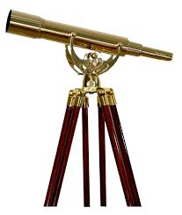](https://www.telescopes.net.nz/shop/Telescopes/Brass/Saxon+15-45X50+Brass+Telescope.html) [](http://etc.usf.edu/clipart/19700/19788/telescope_19788.htm) 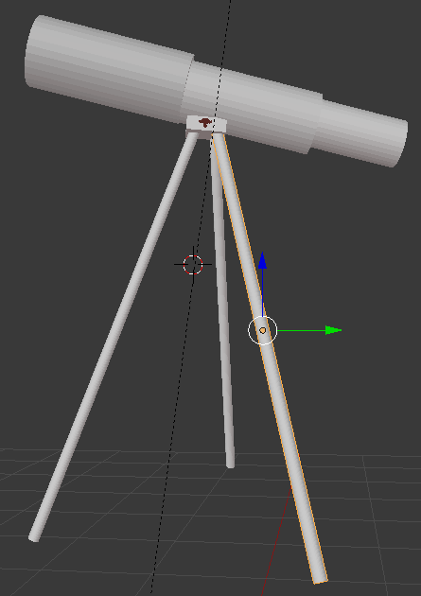

# Studio Workflow

## Idea & Concept

This is where you will come up with the idea of the model.

## Research & Planning

During this phase you will search up what the model will look like and what shapes it can be broken down into for the modelling process. Also the user will search up what tools he will most likely have to use during the modelling process.

## Modelling

This is when the model will be created in the user’s desired modelling software.

## UV Mapping/Texturing

When lighting and textures will be added to the model such as a wood texture.

## Rigging

This is when the “Skeleton” of the model will be added in order for the animation process to learn more go to the “Animation in 3D Modelling” heading.

## Animation

This is when the user will animate the model and make animations like running and jumping to be used in a game. To learn more about the animation process go to the “Animation in 3D Modelling” heading.

# Animation in 3D Modelling

### Path-Based

A commonly used animation system is a path based system, this is when animated objects in a game such as a door will have a path to follow rather than having each frame of it opening being hand drawn.

A path based system is an animation technique used to make animating a certain movement easier for the user, for example if you wanted to anime a ball bouncing up and down you would usually have to hand draw every single frame whereas if you use the path-based technique prominent in most animating software the computer will fill in the blanks itself so all you have to do is draw the ball then tell the computer where you want it to go by setting key frames of the balls original position then where you want its end point to be and it will just repeat the drawing along the path you made making an animation.

[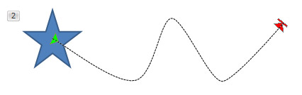](https://www.indezine.com/products/powerpoint/learn/animationsandtransitions/motion-paths-edit-points-ppt2010.html)

### Inverse Kinematics

Inverse Kinematics is a very useful animation technique used by professionals as it saves a lot of time and energy while animating, too describe how this animation technique works I will first have to explain the properties a human model will have in a animation software. A human model will have a skeleton inside it which the animator can edit by having the ability to move each body part individually, put together with inverse kinematics when the animator moves an arm it will also slightly move the other joints connected to the arm making a fluid and realistic motion.

[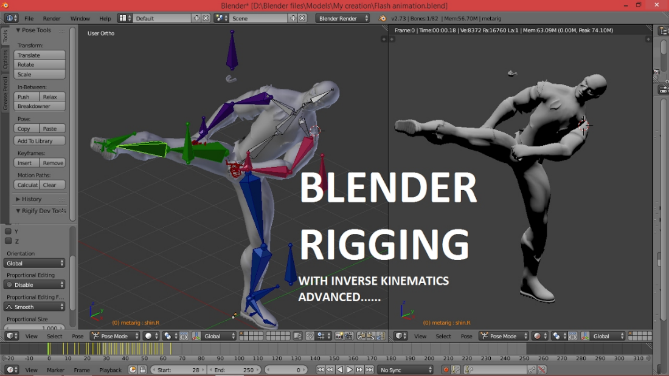](https://www.youtube.com/watch?v=LDDjS4JGv6c)

### Forward Kinematics

Forward kinematics is basically a manual version of inverse kinematics as with this technique you have to move each joint yourself in order to animate the character, not only that but if you were to animate a hand you would have to move the arm before the hand as this goes along with the hierarchy system. Some animators prefer this over inverse kinematics as they feel like they have more control as they can fully manipulate the movements of the character.

### Particle Systems

A particle system is a rendering technique used to produce in game assets such as fire, snow or rain. Fire in games is made up of a large number of tiny sprites in fires case wavering. The particle system will use an emitter acting as a source to produce all the sprites/particles to make up the fire. The particles/sprites produced by the emitter will contain information such as; colour, lifespan, size and velocity all so the particles fit in with the background and what they are supposed to be for example if they are meant to be simulating rain they will have to have the right colour and lifespan so that when they hit the ground they disappear making it look natural.

[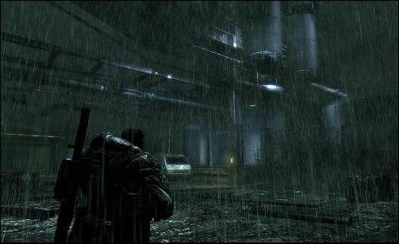](https://www.resetera.com/threads/water-rain-makes-games-look-better.8088/page-2)

# Applications of 3D

## Models

3D is used in modelling all the time as it is just easier to use programs such as Blender and Maya to create models than anything else as you can freely create and move around any object in the program and you can even give the model a skeleton so it can be further improved through adding different animation such as a walk cycle which can then be implemented into a game[](https://www.blender.org/about/logo/) [](https://www.youtube.com/channel/UCHmAXsicpLK2EHMZo5_BtDA)

[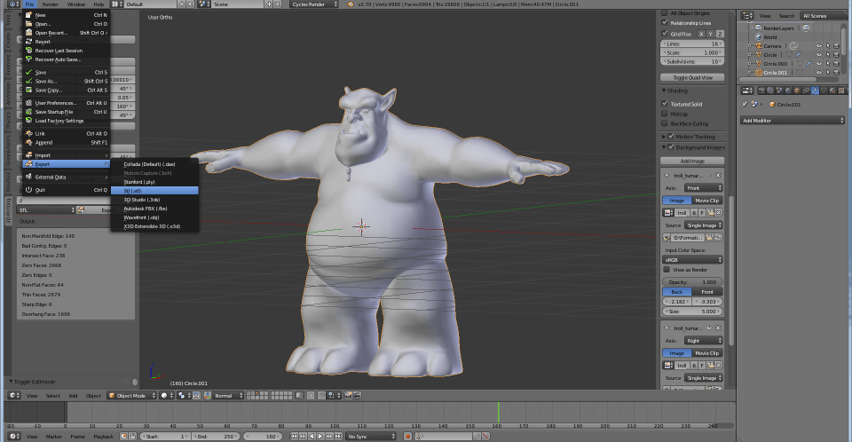](https://www.sculpteo.com/es/tutoriales/prepara-tu-archivo-con-blender/) [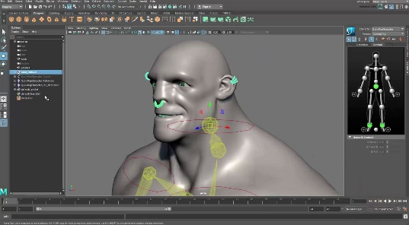](http://www.cgmeetup.net/home/quick-rigging-and-skinning-a-character-in-maya-2017/)

## Product Design

Many engineers and designers are using 3D printers to help model their creations to see how it would work or function in real life, designers would rather 3D print as it is a cheap and a quick alternative to using metal or other materials that would be costly and hard to form into your design. 3D printing will also be really useful for healthcare in the future as scientists are now testing to see if they can 3D print organs with human tissue for transplant surgery.

[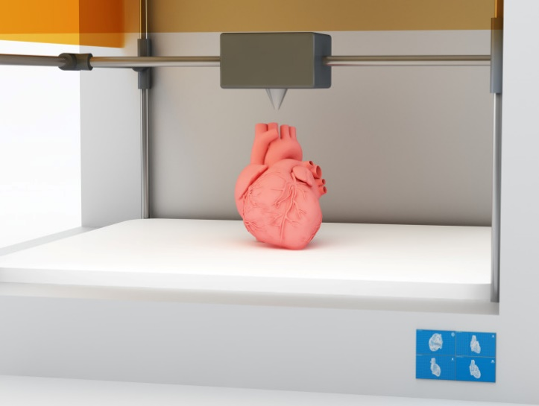](https://www.gizmodo.com.au/2017/11/australians-are-keen-for-3d-printed-organ-transplants/)

## Animations

3D is used all the time in animation especially animated movies to help speed up the time costly process of making an animated feature film. Before this animated movies such as The Lion King which didn’t use 3D to help speed up production used to start development 6 years before releasing in theatres. The first animated film to use 3D computer animated systems was the original Toy Story created by the now widely popular Pixar. As you can see from the picture the animators at Pixar used 3D models of the beloved characters from the movie and moved around their virtual skeleton on the 3D software to move the body. This technique is now used in all the current animated movies such as frozen with the character Olaf as it speeds up the process heavily and allows the user to create a fluid animation because of the software.

<https://www.youtube.com/watch?v=PX1p0lnhQ88>

[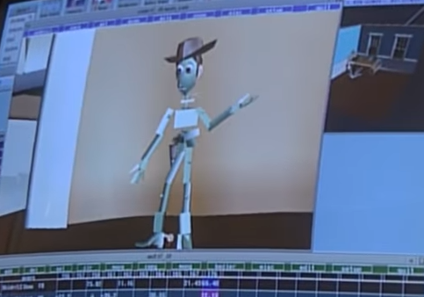](https://www.youtube.com/watch?v=PX1p0lnhQ88)[](https://www.youtube.com/watch?v=z-4c3JSLVww)

## TV & Film

Film and television was the next step from books and theatre to represent storytelling. Most people prefer this form of media over others as it can really immerse someone into a story when watching it your favourite characters play out their lives on a screen. 3D has tried to make its way into the films industry and though it has stayed it has not yet truly immersed the viewer into the movie or program they are watching as I believe 3D is good but it should be implemented again in a few years when it is developed enough to make a worthwhile purchase of a 3D cinema ticket, as currently watching a 3D movie just takes you out of the immersion when watching a movie in the theatres as you have to wear glasses that are already uncomfortable without having to wear them over your prescription glasses and they usually have a smudge or scratch on them, the 3D strains on unused muscles in the eye so you end up feeling tired after the film or you have to keep taking your glasses off in the middle of the film and take a break so you end up missing out on watching the film. Also only about 2 moments in every 3D movie are actually 3D to the point where you feel like you can touch the screen.

[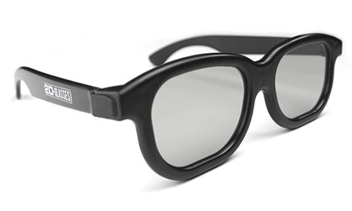](http://3dvision-blog.com/tag/de-3d-cinema-glasses/)

## Web

Many websites are now implementing 3D, however the main one is google maps as on this website you can go anywhere in the world and then look around in 3D. Google maps has two modes; street view which is a 360 degree view put together by google cars going past with 360 cameras on top of them the pictures taken are then merged together to form the pictures down below. The other mode is satellite view where multiple pictures are taken of the same place from different angles to form the picture down below.

[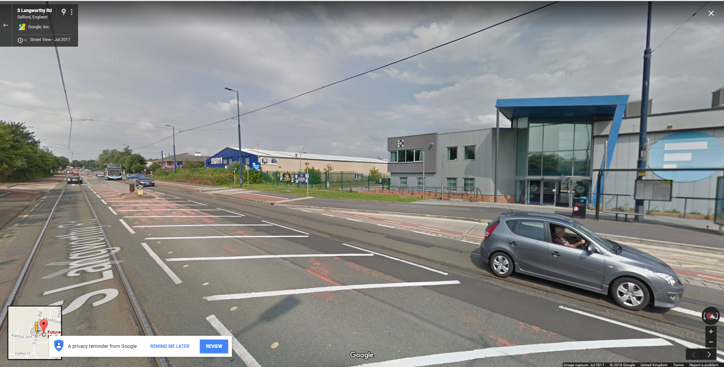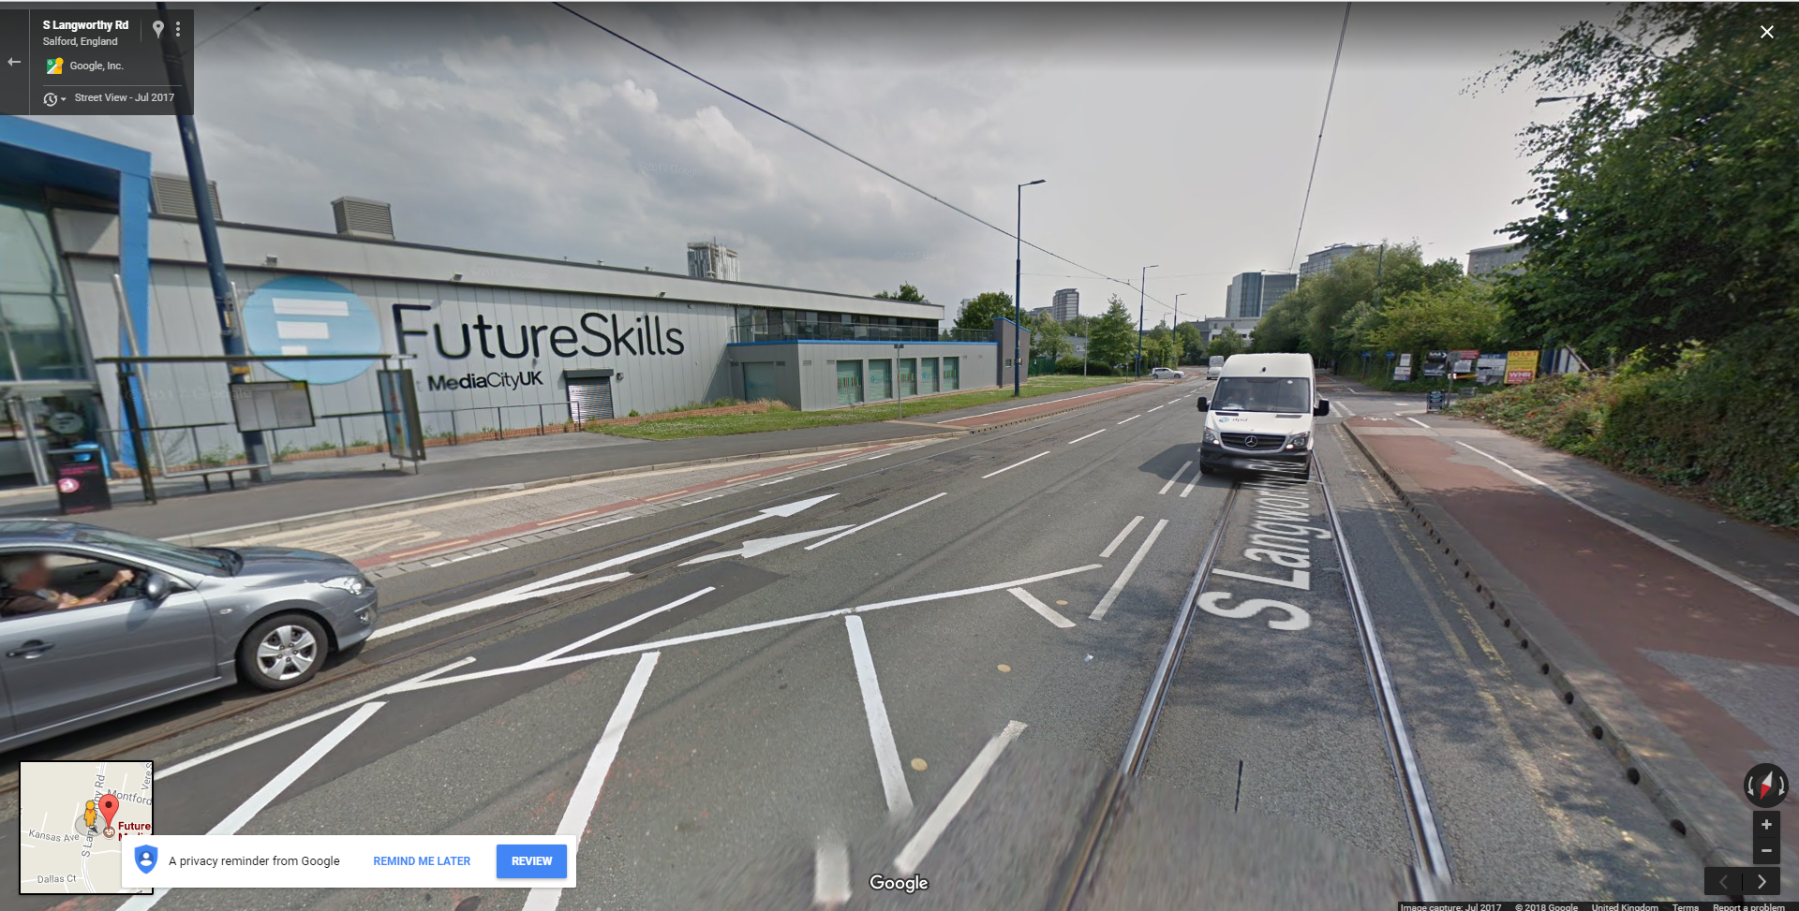](https://www.google.co.uk/maps/@53.4777623,-2.2959708,3a,75y,61.37h,86.17t/data=!3m7!1e1!3m5!1slEbayONlRnlPFHHXp6yUDw!2e0!6s/geo1.ggpht.com/cbk?panoid=lEbayONlRnlPFHHXp6yUDw&output=thumbnail&cb_client=maps_sv.tactile.gps&thumb=2&w=203&h=100&yaw=28.24804&pitch=0&thumbfov=100!7i13312!8i6656)[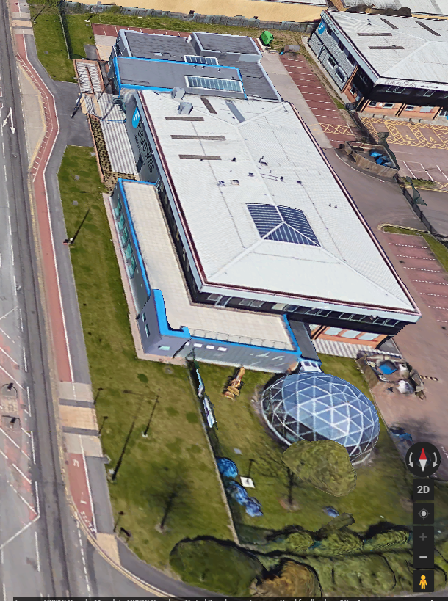](https://www.google.co.uk/maps/place/FutureSkills+at+MediaCityUK/@53.4776204,-2.2965308,291m/data=!3m1!1e3!4m7!3m6!1s0x487bae6a78483ed7:0xaa8f8706109253af!8m2!3d53.477513!4d-2.295108!9m1!1b1)

## Games

### Virtual Reality (VR)

A gaming trend that has recently come into fruition is virtual reality (VR). Virtual reality is a computer generated simulation which is intractable. Virtual reality is mainly associated with the gaming industry with the Oculus Rift, HTC Vive, Samsung Gear VR and finally the PlayStation VR or PSVR for short.

Virtual reality often uses something called 3D VR sound to help immerse the player even more into the world. 3D VR sound is like surround sound except heavily improved as before with surround sound you had an idea of where a shot was fired but you had to guess where the enemy was based off that whereas with 3D VR sound you will be able to pin point where the shot was fired. This is achieved from sculpting a human head and putting microphones where the ears are so the microphones pick up sound exactly as we do in the real world.

[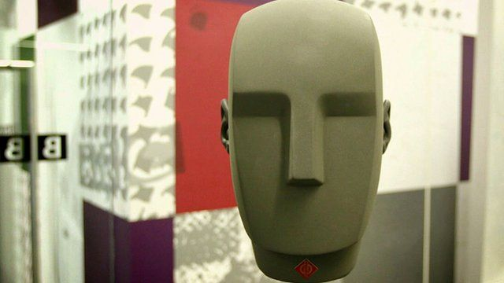](http://www.bbc.co.uk/news/av/technology-36138003/how-this-head-is-helping-give-you-3d-vr-sound)

I believe virtual reality is a current trend but is also one for the future as technology is forever developing and VR definitely needs it as in my opinion currently VR gaming is currently a novelty purchase as there are few games worth playing on the system such as Super-Hot, however with further developments in VR it would become a worthwhile purchase. To make virtual reality worth it for me it would have to have more fun and large games, better graphics in the headset and well the technology present in the movie Ready Player One. In this movie there was an omnidirectional treadmill which is actually real and functional as present by this video however game developers haven't yet implemented it into any major games.

<https://www.youtube.com/watch?v=SVs7iegtDIk>

[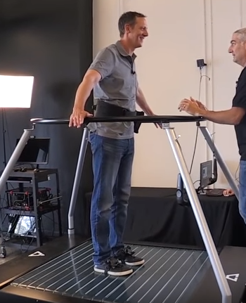](https://www.youtube.com/watch?v=SVs7iegtDIk)

## Education

3D programs can be very helpful when learning as using VR can put you in simulated events that seem real and can be restarted unlike in real life. Meaning that many Doctors can practice specific types of surgery in VR simulations that they would be able to in real life as no patient wants to be practised on whereas in game AI don’t care. In the future I believe the army will also train in 3D simulations to recreate what a true battlefield will be like.

[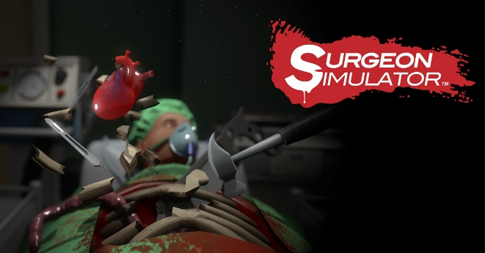](http://www.bossastudios.com/games/surgeon-simulator/)[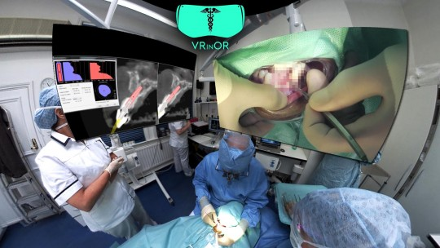](http://www.alphr.com/virtual-reality/1004689/how-samsung-gear-vr-is-helping-to-train-doctors-to-save-patients-lives)

## Architecture

When 3D is applied to architecture it becomes really useful as you can imagine they can make 3D models of buildings to help see how it will look in real life and to see if the dimension seem right. In home improvement shows on television they make 3D models of the owner’s house and then will remove a wall in the 3D model to simulate what the house extension would look like to see if the home owners would want to carry on with construction.

# Displaying 3D

## Application Programming Interface (Direct 3D & OPENGL)

DirectX is a built in system that contains a collection of API’s for the computer to use to communicate to certain programs for example; audio, video and games direct sound. DirectX comes free with Windows and can only be used if your operating system is windows and because DirectX is so good and beats all the other competition most computers run Windows as their operating system rather than something like Linux that uses OpenGL instead of DirectX.

OpenGL stands for Open Graphics Library and is a free graphics API used in operating systems such as Linux, it helps the computer access GPU (Graphics Processing Unit) from this OpenGL will be able to access its built in graphical functions such as; antialiasing, texture mapping, pixel operations and atmospheric effects like fogging and smoke. OpenGL is also open source meaning people will be able to change the code of the API to help improve it although sometimes people will change it to try and hack into the computers operating system or even games.

[](https://mirazmac.info/read/microsoft-directx-all-versions-free-download.html)[](https://www.anandtech.com/show/9506/opengl-siggraph-2015-opengl-es-32-opengl-extensions-announced)

## Graphics Pipeline

[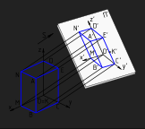](http://dillonmasseyunit66.blogspot.co.uk/2013/01/graphics-pipeline.html)The graphics pipeline is completed by the computers GPU so that you can see the 3D models and graphics in your game. There are many steps that the computer goes through in order to do this.

The first step the computer will go through is vertex processing also named pre-vertex shading and lighting. During this stage the computer will plot out where the model’s vertices will be placed in the cameras view.

## Rendering Techniques (Radiosity, Ray Tracing)

The computer uses the motherboard to help render games for example when you click to shoot in a FPS (First Person Shooter) that process will be sent to the north bridge on a mother board to be rendered. However, if you click too many times and it over powers the north bridge it will be sent to the south bridge to collect until the north bridge is free again to render it. If a game is not rendered properly various glitches could happen such as screen tearing and delayed sound effects.

[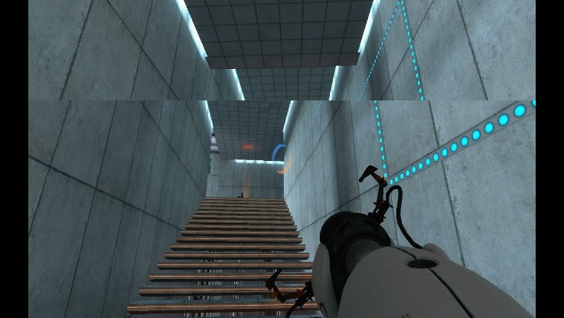](https://www.youtube.com/watch?v=W56cZC8Dk44)

### Culling Methods

Every serious 3D game engine uses the culling method to render graphical objects in a game. The frustum culling method saves processing power by only loading/rendering objects the player can see, their point of view. It also only renders the first face of the object not the back which saves processing power as well.

[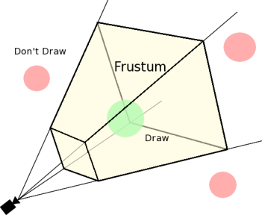](https://leonardogamestudies.wordpress.com/year-2/unit-70-game-engines/assignment-1-task-2-components-of-engines/)

## Lighting

Lighting in video games can set the mood and theme of a game, and the game engine allows the developer to change this. In most game engines the developer can place lights around the world map of a game. With the light function you can control the radius, direction and intensity/brightness of a light, this means you can make a corridor scary or not by making the brightness of the lights lower than usual creating shadows in the game causing the corridor to be creepier than usual to the player. The picture down below is from a horror game, the first image is from the horror game and for the second one I used the brightness tool in Word to increase the brightness to show that lighting can affect the fear of a player.

[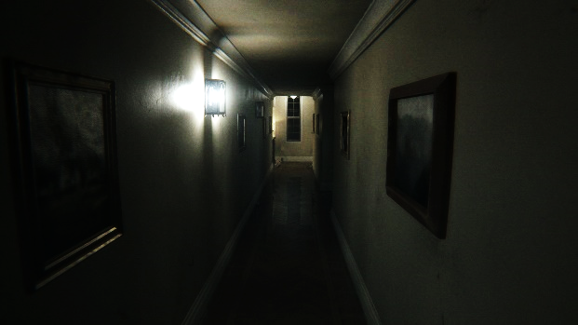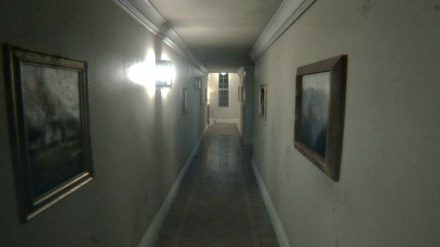](https://videogamesuncovered.com/features/why-p-t-could-be-the-best-horror-game-of-2014/)

## Textures

Textures help the performance of the system while loading up a level in a game because textures make it so the graphics card only has to render one object rather than hundreds of the same. For example in a 2D game there will be an image of grass to be used on the floor this is a texture, the texture will then be duplicated across the floor to make it look like a forest or garden. However the computer will only have to render the original texture making the game run smoothly.

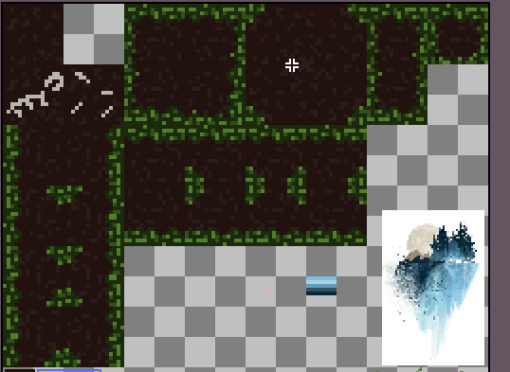

## Shadowing

This technique also helps with increasing the performance of the system running the game, it basically softens the colours of the game by adding fog which makes the game system think there are more white or black pixels which are easier to load, which helps cover up the rendering process for the game. It helps as it disrupts the player’s visions of the in game models for characters and objects do the computer doesn’t have to fully load up the model as the player can’t really see it. Shadowing is the same technique as fogging just reversed as it makes more of the pixels black which the game system can easily render.

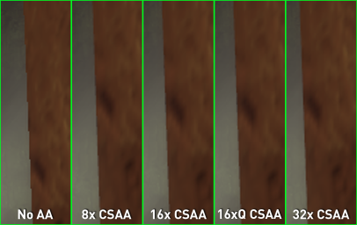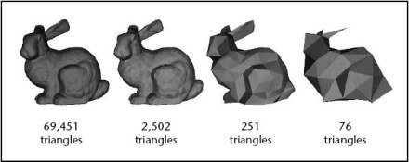

## Vertex/Pixel Shaders

Vertex shaders transform the attributes of an in game objects vertices such as; texture, colour, direction and position. Vertex shaders can quickly tweak a character model while a game is being rendered to make the game look more appealing. Although vertex shaders have many uses they are mainly used to render things like water in games as when the water ripples that is because the vertex shader is constantly changing the height of the vertices to create that simulation.

Pixel shaders is a technique that computers will use to make characters and objects look better, as this is the technique that defines what the colour of each pixel should be while also working out how to change the pixels to represent light hitting the object or a shadow casting over it.

# Geometric Theory

## Vertices

The vertex of an object is the point of intersection between three or more edges, basically the tip of an object. In 3D modelling applications the vertices are the three co-ordinates that are used to move an object around X, Y and Z. Also in most 3D modelling software the vertices of an object are manipulated by pushing and pulling it to change the shape of an object.

[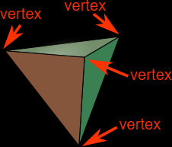](https://www.mathsisfun.com/geometry/vertices-faces-edges.html) [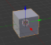](https://hackaday.com/2014/01/03/3d-printering-making-a-thing-in-blender-part-i/)

## Lines/ Curves

Lines and curves are the main body of models which can be changed in height to make an object bigger or smaller.

## Edge

The edge of an object is any point on the surface of the 3D model where two polygonal faces meet, these are often used to join vertices together.

## Polygons

Polygons are used throughout the entire modelling process as they make up the main body of the model. The simplest form of a polygon is three vertices connected by three edges so basically a triangle. Polygons are still used today there are just a lot more of them to the point where you can’t see them. However game characters used to only have a few polygons in there model meaning you could see the rigid polygonal shape. The number of polygons a model has is called the poly-count and the polygon density is called the resolution, the higher the poly-count and resolution of a model the smoother and in my opinion better a model will look. Down below is a comparison between the low-poly Mario and the latest Mario model (Super Mario Odyssey) which do you think is better?

[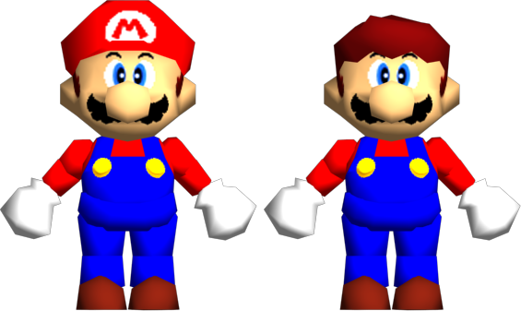](https://www.marioboards.com/index.php?topic=38871.0)[](http://thelcbridge.com/super-mario-odyssey/)

## Faces

The face of an object is the part of the model which you actually see meaning they are very important the entire process of modelling, 3D models usually contain thousands of geometric faces.

## Meshes

The mesh of a 3D model is made up of a collection of vertices, faces and edges which allows the model to be rendered more easily and quickly as the mesh make all of the object one so there is less values for the computer to use.

## Surfaces

Surfaces are basically textures/colour variants that you can apply to specific polygons or set of objects such as with a plain you could add a present wood texture that comes with the modelling software and call it the floor of a house. There are more difficult texture to make as well which are made to be applied on a specific model such as a face of a character looks like the picture below and is then wrapped around a head to form the character.

[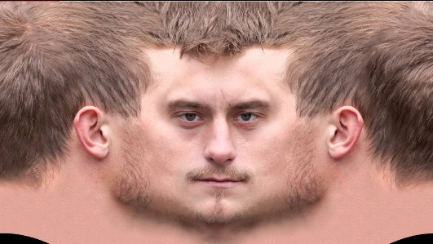](https://www.youtube.com/watch?v=SVqWvlNNHo4)

# Mesh Construction

## Common Primitives (Cubes, Pyramids, Cylinders, Spheres)

Primitives are basically common/simple 3D objects that are put into 3D modelling software such as Blender pre-made for the user to use at their will. These shapes are extremely useful as if you break down any model or drawing down they will contain these shapes such as spheres, cubes and cones.

[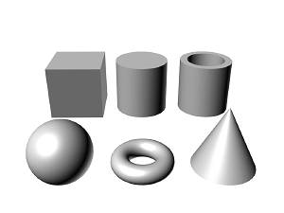](http://cparisunit66.blogspot.co.uk/)

## Box Modelling

Box modelling is basically a technique where someone will use a simple primitive object such as a cube and will make that the final model of the piece. Although they will alter the shape in some way by adding textures, changing the indentation of the faces and vertices of the object to make it look less “blocky” and various other things.

## Extrusion Modelling

Extrusion Modelling or otherwise known as inflation modelling is basically a method of using 2D pictures of the same subject from different angles and converting them into a 3D version of that picture. This is mostly used to recreate a character or put a real life person’s face in a game.

# 3D Software & Development

## Software (3D Studio, Maya, Lightwave, Autocad, Cinema 4D, MudBox, Blender)

There’s many 3D modelling software’s out there including; 3D Studio, Maya, Lightwave, Autocad, Cinema 4D, MudBox, Blender. However I am only going to focus on Maya and Blender.

### Maya vs Blender

Both 3D development programs can do the same thing and are both very viable in the professional gaming industry however here are a few points to why you would want to go for Maya or Blender. Maya and Blender are the two most popular programs for 3D modelling currently.

#### Maya

The main benefit of using Maya is that it is more widely used in the gaming industry, Maya has also got one of the best animation tools backed up by some decent VFX and rigging tools. Although an issue with Maya being so widely used is that it never innovates because if it did their user base would most likely be outraged however this means other 3D modelling programs have more tools such as Blender. Also, the price point is very high meaning for indie developers it can take a lot out of their budget.

#### Blender

A massive plus of blender is that its free to use meaning that anyone can use blender as long as they have a computer and this is also good for indie developers on a small budget will not have to take a huge chunk out of their budget just for the modelling software and can spend it on other things to make the game development a smoother process. Another benefit of Blender being free is that the community is more widespread providing more free tutorials on YouTube than with Maya. A problem with Blender is that because its new not many companies use it professionally so you would probably have to transfer to another program probably Maya. Also because Blender is free it’s not as refined as other 3D modelling programs causing the user interface to not be very user friendly.

## File Formats (3DS, .MB, .LWO, .C4D, .DXF, .OBJ)

There are many file formats for saving 3D models which include; 3DS, .MB, .LWO, .C4D, .DXF, .OBJ. This is because each of the modelling software uses their own file format to save the models created on their platform so that you can say make a model on Maya and then open it up on Blender. Each file format also comes with its own advantages and disadvantages for example one could compress files quickly and more but lose out on quality in order to make the file size smaller which is good for games to keep the download for the user low.

# Constraints & Resolution

## File Size

File size is a big problem with 3D models as they take up a lot of space since there is a large amount of information stored into the model such as textures and various over things. To decrease the file size of a 3D model you should rather decrease the image resolution or image quality. Other ways you could perhaps decrease the file size of your model is by getting rid of a couple of unnecessary textures and lights.

### Image Resolution

Resolution refers to the number of pixels in an image. Resolution is defined by the width and height of the image as well as the total number of pixels in an image. For example, an image that is 1920 pixels wide and 1080 high or referred to as 1920X1080 contains 2,073,600 pixels. Another way resolution can be measured is by the acronyms DPI (Dots per Inch) and PPI (Pixels per Inch) the higher the DPI the larger amount of detail the image has. [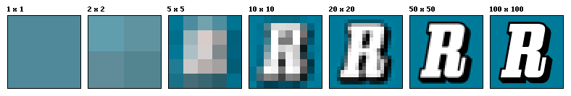](https://en.wikipedia.org/wiki/Image_resolution)

[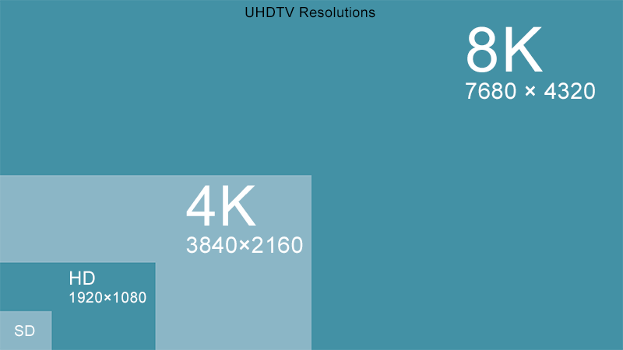](http://www.mediacollege.com/video/resolution/)

### Image Quality

The image quality is measured on how accurately the image represents the subject of the whole display. This can be defined by how well the brightness, contrast, resolution, geometry and colour matches the intended subject. As you can see from the photo lighting is usually controlled with camera lights and contrast is normally controlled with a white background, these can also be changed in programs such as Photoshop. [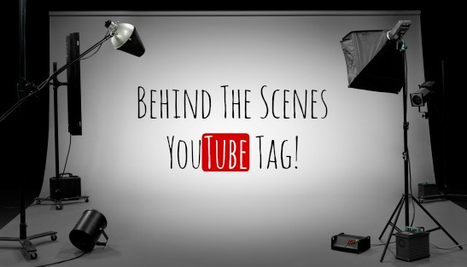](http://www.mamakatslosinit.com/2014/11/behind-scenes-youtube-tag/)

The quality of the image can also be manipulated “compression”. An uncompressed image is saved in a file format that doesn’t compress.

## Rendering Time

Rendering a 3D image can take a substantial amount of time as the graphics card must generate the 3D model into a 2D scene which is very demanding on the computer. With some rendering engines it can take even longer depending if you want the resolution of the image to be higher. One way to increase the rendering time is by linking up the computers to focus all of the combined processing power on the image, this is still used by professionals and is common for making an animated film.

## Compression

Compression is needed to decrease the sizes of files so you don’t run out of storage, it does this by using a certain technique to remove any unnecessary data of an image. The most common form of compression is to zip a file by zipping a file it gets rid of all unnecessary information the file may have.

A way of decompressing a file is to use WinRAR or WinZip which will get the file back to its original size and if done correctly will be identical to the original copy. You can also compress multiple files at once.

[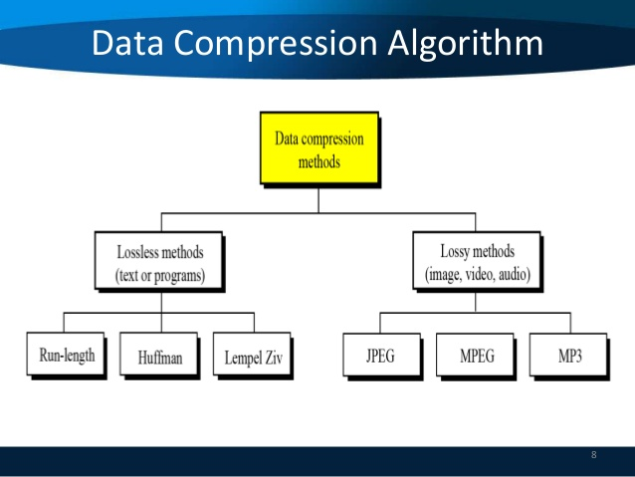](https://www.slideshare.net/sherifghoname/data-compression-28115182)

### Lossy

[](http://www.makeuseof.com/tag/all-you-need-to-know-about-video-codecs-containers-and-compression/)This is a type of data compression which uses technology to delete unnecessary information which makes pictures have less quality. Therefore word documents and other types of text documents don’t use lossy as if they did then when the user reopened the file there would be words missing. Vector graphics and JPEG files use lossy compression.

### Loss Less

This allows you to compress a file and still keep everything, all the data that is on that file so if you save a music track with lossless compression when you open it up and play it, nothing will be missing and the song will have everything in it. Whereas if you were to save a music track using lossy compression and then replay it usually wouldn't sound the same as there would be a loss of audio quality. It manages to do this by eliminating redundant information or shortening information such as if in picture multiple pixels are the same colour it will code it so there are 45 blue pixels instead of saying “blue pixel, blue pixel …” Raster graphics use loss less compression.

# Conclusion

## Here to Stay?

3D models and modelling are of course here to stay however technology might advance tremendously to the point where computers can basically make the model for you.

## Future Applications?

I believe the future applications of 3D will mostly just be integrating 3D printing machines into normal society by dropping the price of it and making the interface more user friendly, I feel the best way to do this will be to implementing it into the school system as then children will know how to use it when they grow up and they will get their parents to buy a machine.